Web Development Lesson Plan

|  |  |  |
| --- | --- | --- |
| Session: 3 | Topic: Introduction to Django | Day: 3 |

|  |
| --- |
| Lesson Objective:  This exercise will...   * Introduce the Django Python web development framework.   The purpose of this lesson is also that   * Students will be able to understand the basic functions and benefits of the Django development framework. |
| Materials Needed:   * Internet access * Web browser |
| Agenda:   1. What is Python (5 minutes) 2. What is Django (20 minutes) 3. Why Django? (10 minutes) 4. Reflection (5 minutes) |
| Procedure:  Student can do this fully independently by reading the instructions, or someone can read the instructions to make sure the task is understood before doing the activity. The reflection part can be done with guided instructions, or in pairs with other students if available to compare notes. |
| Assessment/Check for learning:   * Students can identify concrete things that they missed in their observation (note that this is not a bad thing, the purpose of this lesson is to realize that intentionally looking for information comes with the ‘penalty’ of reduced attention to other things. |

What if:

* Student has already shown proficiency in that skill?
  + Pick a movie or episode in which a lot of things are happening, so that there are more things for the student to keep track of.
* Student is having a hard day and needs special accommodations?
  + Pick a movie or episode in which only a few things are happening, so that there are less things for the student to keep track of.
  + Instead of writing, the student can also take spoken notes with an audio recorder. This will be a bit trickier in the second part but audio in the movie can be supported with subtitles.

NOTES:

* Duration is approximately 50 minutes; can be adjusted by shortening the duration of the film clip. Less than 10 minutes is not recommended unless really necessary.

**Instructions**

**What is Python (10 minutes)**

Step 1:

Python is a popular programming language that is extremely robust. It is also easy to learn compared to traditional programming languages such as Java or C. Python is used in many areas such as data analytics, automation, artificial intelligence, and web applications to name a few. Watch the following video to learn more about Python:

[What is Python? Why Python is So Popular?](https://www.youtube.com/watch?v=Y8Tko2YC5hA)

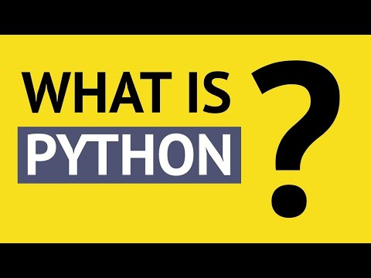

**What is Django (20 minutes)**

Step 1:

Django is a web framework built with Python. It allows web developers to quickly create complex web applications. Django allows quick setup of user authentication, templating, routing, creation of databases, and much more. Read the following article to learn more about Django:

<https://developer.mozilla.org/en-US/docs/Learn/Server-side/Django/Introduction>

**Why Django? (10 minutes)**

Step 1:

There are many web development frameworks to choose from, some have better features than others. Django is a complete framework that offers developers all the tools they need to quickly create interactive and complex web apps. Other frameworks require addons and can be tricky to scale. This is not the case with Django, as it offers enough features to allow developers to handle the back-end and front-end of a web app. Django also offers built-in security features that prevent clickjacking, cross-site scripting, SQL injection, and other common web threats. It is also possible to build web apps that can run as iOS or Android apps. Read the following article to learn why Django is preferred by many:

<https://www.freecodecamp.org/news/10-reasons-to-try-django-for-client-projects/>

Step 2:

Django is used for all kinds of projects. Hobbyists use Django to quickly prototype their ideas. Small companies use Django to manage operations. Django is even used by large organizations such as Instagram, Spotify, and Pinterest. Read the following article to learn about how popular companies use Django:

<https://medium.com/@thakuramit92/8-popular-companies-use-django-for-their-web-applications-531cdd21ac38>

**Reflection (5 minutes)**

What is one question you have about the Django framework?

List a few benefits of using the Django framework.

In the following lesson you will be begin to setup your development environment to start coding.